2.2: (Non)parametric testing
4. (a)Table 1: One-sample t-test
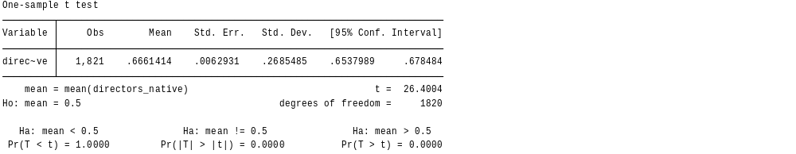
The p-value= 0.0000 is less than the significance value of 0.05, and we reject the null hypothesis and conclude that the share of the native board members is significantly different from 50%. A mean value of 0.66 confirms that it is higher than 50%.
(b) Table 2: Two-sample t-test testing ROE
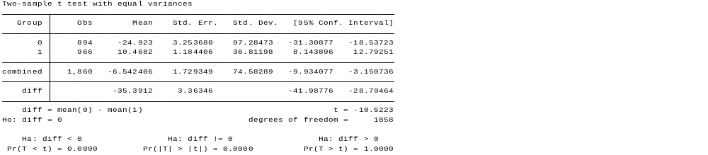
The p-value of 0.0000 is less than the significance value, and we reject the null hypothesis. We therefore conclude that the ROE is higher for companies with higher total assets. In addition, the mean difference is -35.3912, as the mean for companies with higher assets is 10.4682, while that of companies with smaller assets is -24.923.
© Table 3: Paired t-test testing ROE and ROCE
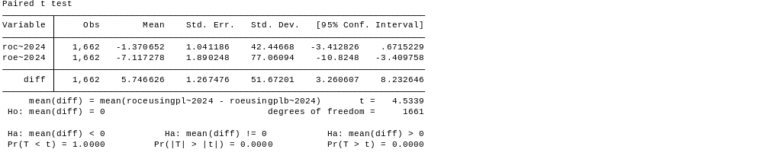
With a p-value of 0.0000, which is less than 0.05, we reject the null hypothesis and conclude that ROCE is higher than ROE. From the results, the difference of 5.756626 confirms that ROCE is higher than ROE by the same percentage points.
5. Table 4: Contingency Table of ROE Quartiles by Asset Size
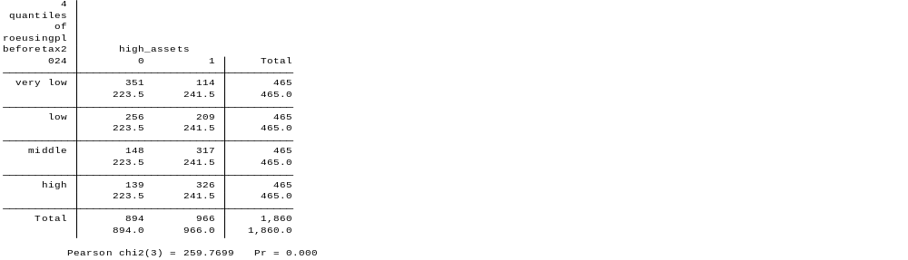
With the least frequency being 223.5, the contingency table is appropriate for performing the test of association because all the expected frequencies are much greater than 5; therefore, no adjustments are needed. The p-value is less than the significance value, and we reject the null hypothesis, concluding that there is a significant association between company size and the profitability of the assets. In addition, the results reveal that most companies in the sample tend to perform better in terms of profitability compared to smaller companies, with the very low ROE category being 351 and 139 in the high category for companies with low assets. On the other hand, the vice versa happens with 326 companies in the high ROE category, with only 14 companies in the very low categories for the high assets companies.
6. Table 5: Two-sample t-test of ROE by Industry Type
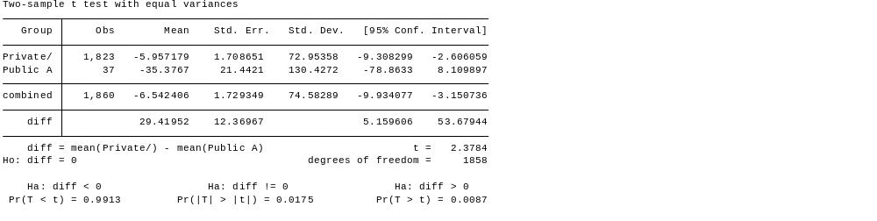
With the mean difference of 29.41952, the private companies have an ROE that is 29.41552 percentage points higher than the pubic administration firms. The p-value of 0.0175 is less than the significance value, and we conclude that the difference is statistically significant.
Table 6: Multiple Linear Regression of ROE on Total Assets and Public Administration Sector
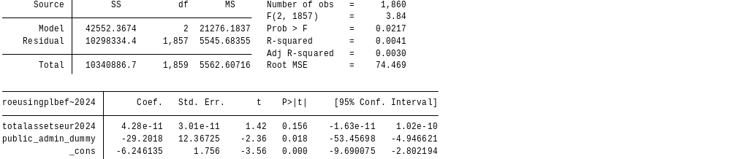
Public administration dummy is significant with a p-value of 0.018. Holding all factors constant, the profitability of the public administration firms is 29.2018 percentage points lower compared to other companies. Total assets do not have a significant influence on the firms’ profitability, with a p-value of 0.156. The total variation explained by this model is 0.41%, and therefore, public administration and total assets explain less than 1% of total profitability, and the critical variables influencing profitability are not included in the model.
7(a): Table 7: Wilcoxon Rank-Sum (Mann-Whitney) Test of ROE by Industry Sector
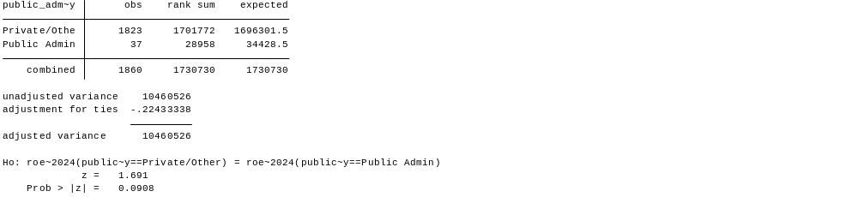
From the rank-sum analysis, the rank sum(28958) of the public administration is less than the expected sum(34428.5) and therefore, the ROE for the public administration firms is lower. The p-value of 0.0908, which is higher than the significance value, and we fail to reject the null hypothesis, concluding that there is no statistically significant difference in the distribution ranks between the two groups at a 5% level.
(b) Table 8: Jarque-Bera Test for Normality of Director Age.
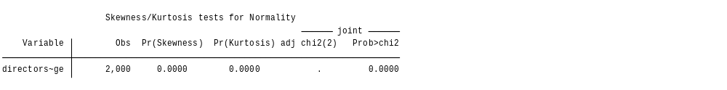
With the Pr(skewness) being 0.0000, it is statistically significant that the directors' age data is asymmetrical, and it therefore might be leaning more to the right or to the left. In addition to this, the Pr(kurtosis) value of 0.0000 reveals that the thickness of the tail is not the same as that of normally distributed data, and the data might have very many extreme values or be too flat.

Figure 1: Graphical Analysis of Director Age Distribution (Box-plot)
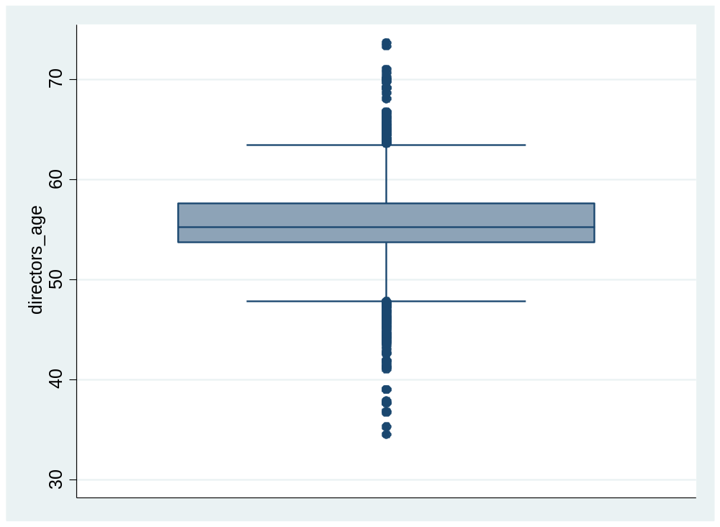
With the median line appearing not perfectly centered, the data for the directors' age is skewed and not symmetrical. Most of the directors in the firms seem to be generally younger since the line leans more to the lower part than the upper part. The box plot also reveals that there are outliers, which also support the finding that there are long tails, especially on the lower side.
Figure 2: Graphical Analysis of Director Age Distribution (Q-Q Plot)
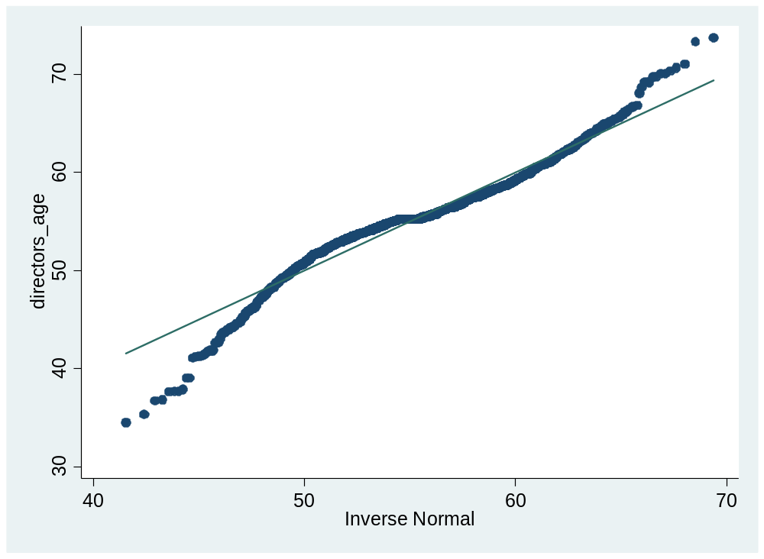
The Q-Q plot reveals that the data does not stick to the 45-degree line and therefore, the data is not normally distributed. The dots deviate from the required normal distribution, so we make the conclusion that the data is skewed.
From the box-plot and the Q-Q plot, the two figures visually support the finding that the directors' age data is not symmetrical and not normally distributed.

©. Table 9: Wilcoxon Signed-Rank Test Comparing ROE and ROCE
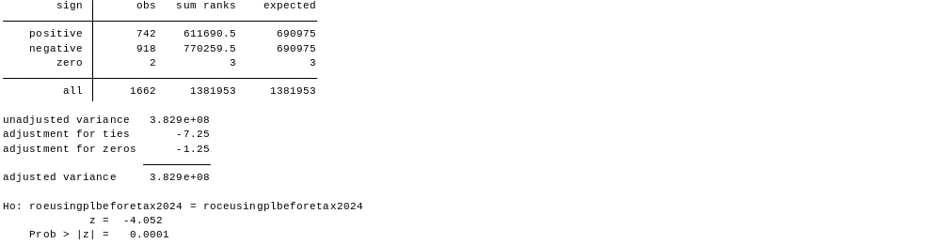

From positive and negative signs respectively, there are 918 firms where ROCE is higher than ROE, while the firms where ROE is higher than ROCE are 742. The negative z-value of 4.052 explains that the negative sign, where (ROCE>ROE), dominates the sample. From the p-value, which is less than the significance value, we reject the null hypothesis and conclude that ROCE is higher than ROE in the sample. From this, there is a revelation that the firms do not effectively use their debts to have better returns for the shareholders.
2.3: MULTIVARIATE REGRESSION 1
(a)Table 10: Tabulation of Extreme Outliers in Total Assets
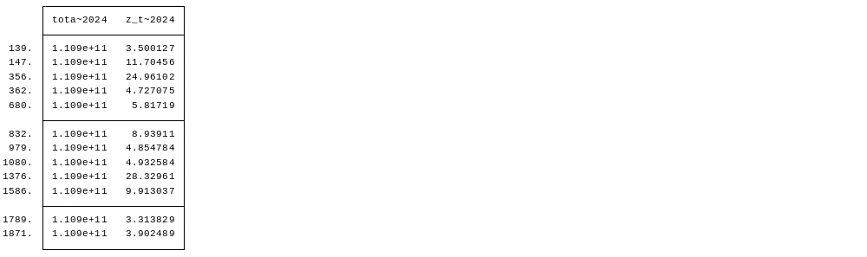
By calculating the standardized z-scores for total assets, outliers are identified, and they explain the deviation from the average point. Because these values are greater than three, the data is interpreted to be rightly skewed, which would result to biasness in linear regression.
Figure 3: Boxplots for remedied assets data
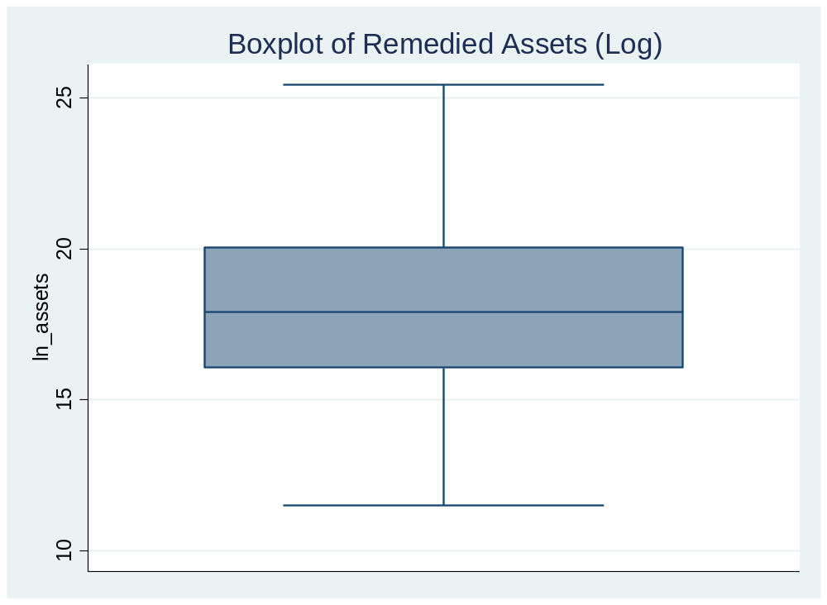
From the boxplot, the median line is centrally placed, and the data is symmetrical now. There are no more dots past the top or bottom of the plot suggest that the data is normally distributed now, without the data having heavy tails. The whiskers are equal, which confirms that the data is not skewed but symmetrical. From the visualization, the remedy applied makes the data normally distributed.
(b)Figure 4: Scatterplot of directors' age vs. gender
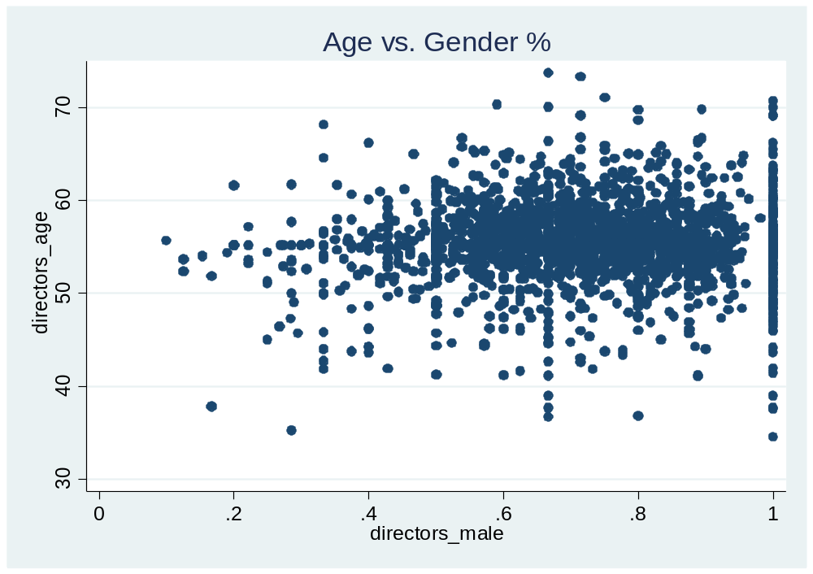
Most of the directors are aged between the age of 50 and a little past 60 years. There are many plots below and above the scattered area, and they are outliers. By running a regression model, maintain the observations to capture full board structures by using robust standard errors.
Table 11: Multivariate Regression of Firm Performance (ROE) on Board Composition and Firm Size"
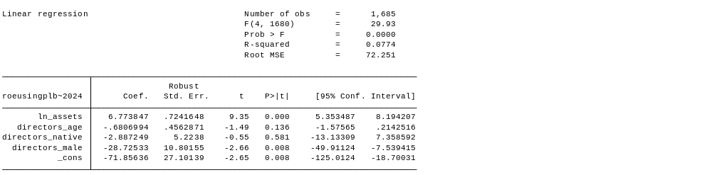
With a p-value of 0.0000 on ln_assets, the model is statistically significant, and the combination of board characteristics and firm size affects profitability. The R-squared reveals that overall model fit is acceptable, with the variables explaining 7.74% of the variation in ROE, with the rest being explained by external factors such as market conditions, which are not included in the model. From the model, firm size is the strongest predictor of ROE. With a negative and significant coefficient on directors_male, and therefore, the firms with fewer males seem to be performing better than the firms where all staff are male, and gender diversity is greatly encouraged. With most ages ranging between 50 and 60, the effect of directors' age does not significantly impact the ROE.
©: A natural log transformation helped generate the ln_assets variable. After the original version (totalassetseur2024) had extreme outliers. After the transformation, the tail of the distribution is inward, creating data that is a little more normally distributed. The final sample used as depicted in the regression model is 1685 observations, unlike the original sample of 2000 observations, where the outliers have been corrected. A technical remedy of applying robust standard errors was used to get rid of data bias from the outliers while at the same time maintaining valuable data.
9.
Table 12: Regression Results for Firm Performance (ROE) with Log-transformed Assets
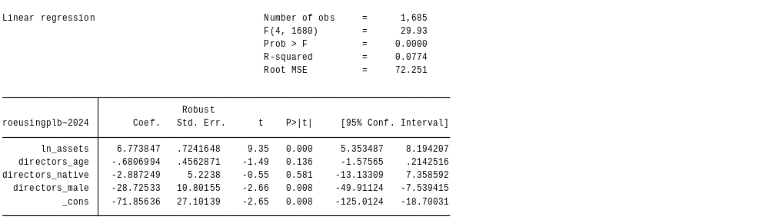
Regression line:
ROE = -71.86 + 6.77(ln_assets) - 0.68(directors_age) - 2.89(directors_native) - 28.73(directors_male)
From the positive coefficient of the ln_assets variable, 1% increase in total assets of a company increases the ROE by 6.773847. The percentage comes from the log transformation. Larger firms are significantly more profitable compared to the smaller firms. An addition of a director's age by one unit results in a decrease in the firm’s profitability by 0.6807 units. However, this effect is not statistically significant since the p-value of the variable from the regression model is higher than the significance level. From the results of the directors_male variable, with a negative and significant coefficient, the addition of a male employee in the company reduces the profitability of the company by 28.7253 units. From this, the company should embrace diverse genders (more females) to increase its profitability. Having an international board increases the profitability of a firm by 2.8873, which has a negative coefficient, depicting that having a local board reduces the profitability of the firm by the same units. This effect is, however, insignificant since the p-value is higher than the significance level.

